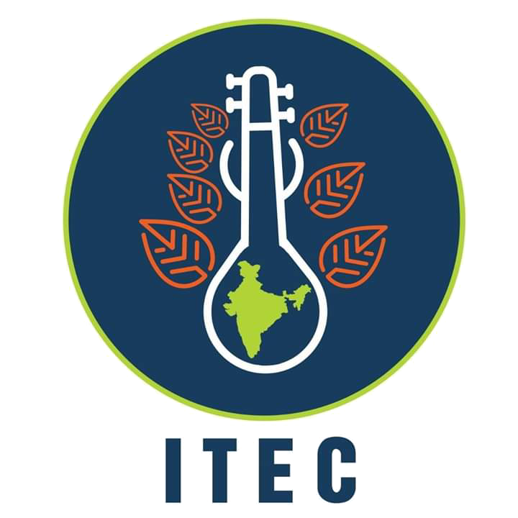
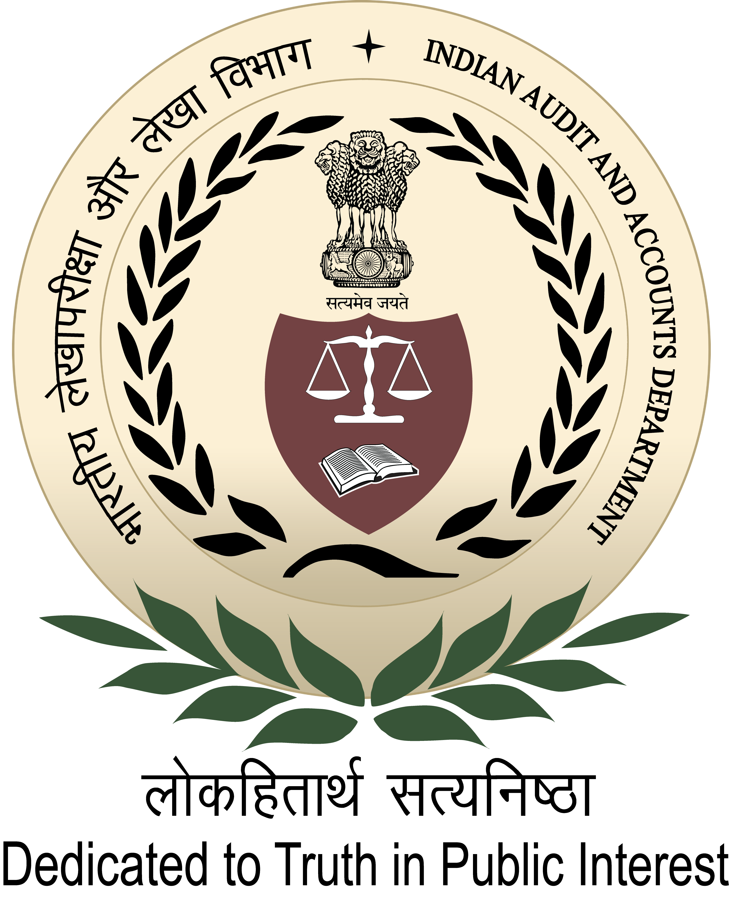

International Centre for Information Systems & Audit
A-52, Sector- 62, Institutional Area, Phase-II, Noida – 201307 (Uttar Pradesh)

150thInternational Training Programme

on
“Audit of e-Governance”
(06th to 31st January, 2020)

Course Schedule

150th ITP Firstweek
Date & Day | Session 1  10:00– 11:15 Hours |  | Session 2  11:45 –13:00Hours | Session 3  14:00 – 15:15 Hours | Session 4  15:45 –17:00Hours
06 Jan. 2020  Monday | Briefing & Ice-breaking session |  | Introducing India | Inauguration at SAI India HQrs (C&AG of India)
Presentation by
SAI India participant
 | Room no. 108 |  |  | Seminar Hall
07 Jan. 2020  Tuesday | Overview of e-Governance In India |  |  | Data Analytics in Public Audit:  Principles and approach |  | Data analytics tool “Knime”: Overview and hands-on sessions
 | Mr. K R Sriram, IAAS  Director General, iCISA |  |  | Mr. Abhay Singh, IAAS  Deputy Director(R&I), iCISA
 | Room no. 213
08 Jan. 2020 Wednesday | Issues and challenges of e-Governance Projects:  An Implementer’s Perspective |  |  | Digital transformation through  e-Governance and Strategic Issues for IS Auditors
 | Mr. Tanmoy Chakrabarty,  Group Government Affairs Officer, Tata Sons Limited |  |  | Mr. J Satyanarayana, IAS (retd)
 | Room no. 213
09 Jan. 2020  Thursday | OIOS: SAI India’s IT initiative | Use of Drones, Remote sensing Photographs, GIS in Audit |  | Risk assessment in e-Governance Projects
 | Ms. Monica R, IAAS  Deputy Director (IS-IV) |  |  | Mr. Bramhanand Jha , Sr. Consultant, NeGD, MeitY
 | Room no. 213
10 Jan. 2020  Friday | Evaluation of e Governance initiatives in India and risk areas in implementation |  |  | Introduction to Digital Forensics: Digital Evidence Control;  Recovering files & Analysis and Reporting
 | Dr. Arunabha Mukhopadhyay  Professor, Indian Institute of Management, Lucknow |  |  | Mr. A. S. A. Krishnan  Senior Consultant, STQC, MeitY
 | Room no. 213
11 Jan. 2020  Saturday | Agra visit
12 Jan. 2020  Sunday | Social programme

150th ITP Second week
Date & Day | Session 1  10:00 – 11:15 Hours |  | Session 2  11:45 – 13:00 Hours | Session 3  14:00 – 15:15 Hours | Session 4  15:45 – 17:00 Hours
13 Jan. 2020  Monday | Data Analytics tool “Knime”:  Hands-on sessions |  |  | Change Management in  e-Gov projects |  | e-Gov: ICT creating Rural Entrepreneurship through CSC scheme
 | Mr. Abhay Singh, IAAS  Deputy Director(R&I), iCISA |  |  | Mr. Ashis Sanyal  Senior Director(Retd.), MeitY
 | Room no. 213
14 Jan. 2020  Tuesday | Integrity issues in e-Procurement systems:  Underlying Risk areas and related Best practices |  |  | Audit of e-Procurement : a case study
 | Mr. Jitendra Kohli  Managing Director, ElectronicTender.com(India) Pvt. Ltd. |  |  | Mr. Vikash Kumar, IAAS  Deputy Director(IS)
 | Room no. 213
15 Jan. 2020  Wednesday | Planning of Audit of IT Governance, Acquisition & Development |  |  | Audit of Controls, Outsourcing including Service Level Agreement and O&M
 | Mr. K R Sriram, IAAS  Director General, iCISA |  |  | Ms. Vani Sriram, IAAS,  Director General (NER-II)  O/o the C&AG of India, New Delhi
 | Room no. 213
16 Jan. 2020  Thursday | Cyber laws and legal issues in implementation of e-Governance projects | Data Privacy : Concepts, Issues and implications, Right to be forgotten |  | Introduction to  OWASP Top 10 vulnerabilities and  Web Application security
 | Rahul Sharma, Ex-DSCI |  |  | Mr. Apurv Kansal  Cyber security expert
 | Room no. 213 |  |  | Room no. 111
17 Jan. 2020  Friday | Introduction to Cloud Computing:  Concept & Security Concerns |  |  | Direct Benefit Transfer - Audit of PAHAL- A case Study
 | Mr. Iqbal Singh  Director – Cloud Deployment, Nokia |  |  | Mr. Sony Joseph  O/o the PDCA & ex-Officio MAB-II, Mumbai
 | Room no. 213
18 Jan. 2020  Saturday | Delhi visit
19 Jan. 2020  Sunday | Social programme

150 ^{th} ITP Third week: Study tour & case studies
Date & Day | Session 1  10:00 – 11:15 Hours | Session 2  11:45 – 13:00 Hours | Session 3  14:00 – 15:15 Hours | Session 4  15:45 – 17:00 Hours
20 Jan. 2020  Monday | Study Tour to Hyderabad
21 Jan. 2020

Tuesday
22 Jan. 2020

Wednesday

23 Jan. 2020

Thursday
24. Jan 2020  Friday | Country papers on “Audit of e-Governance” of respective SAIs |  | Mobile Computing and Issues for audit
 | Presentation by the participants |  | Ms. Swati Sharma, Amazon
 | Room no. 213
25 Jan. 2020  Saturday | Social programme/Activity
26 Jan. 2019  Sunday | Social programme/Activity

150th ITP Fourth week
Date & Day | Session 1  10:00 – 11:15 Hours |  | Session 2  11:45 – 13:00 Hours | Session 3  14:00 – 15:15 Hours | Session 4  15:45 – 17:00 Hours
27 Jan. 2020  Monday | Theme country day |  |  | Country papers on “Audit of e-Governance” of respective SAIs
 |  |  |  | Presentation by the participants
 | Auditorium |  |  | Room no. 213
28 Jan. 2020  Tuesday | Introduction to IDEA:  Importing Data files, Obtaining an overview of the data | Hands on sessions :  Functions in IDEA and Extracting data relevant to audit |  | Hands on sessions :  Gathering evidence for errors in application controls & Audit Sampling using IDEA, Audit of e-Governance Projects using IDEA
 | Mr. K P Singh, SAO (Retd)
 | Room no. 111
29 Jan. 2020  Wednesday | Case study on Audit of Odisha Secretariat Workflow Automation System (OSWAS) |  |  | Audit of Government to Consumer (G2C) Interaction-  Case study on Audit of e-District
 | Mr. R. P. Rath, SAO, O/o the AG (G&SSA), Odisha, Bhubaneswar |  |  | Mr. Abdul Barri, SAO  O/o the PAG (G&SSA), Tamil Nadu & Puducherry
 | Room no. 213
30 Jan. 2020  Thursday | Country papers on “Audit of e-Governance” of respective SAIs |  |  | Case study :  Drug Logistics Information & Management System(DLIMS)
 | Presentation by the participants |  |  | Mr. K P Singh, SAO (Retd)
31 Jan. 2020  Friday | Country papers on “Audit of e-Governance” of respective SAIs |  |  | Valediction
 | Presentation by the participants
 | Room no. 213 |  |  | Room no. 213

